**TITLE IN ENGLISH**

**TITULO EM PORTUGUÊS**

**TÍTULO EN ESPAÑOL**

* + - 1. **Author's full name without abbreviations[1]**

**Recibido: 31/05/2024 | Aceptado: 01/06/2024 | Publicación en línea: 28/06/2024.**

**Abstract**

The abstract of the forthcoming publication aims to provide a concise overview of the study at hand. Considering the justification and underlying problem, the objective is to clearly define the research objectives. To do so, an appropriate and well-founded methodology will be followed. Thus, upon analyzing the results obtained, significant contributions to the field of study are observed. These findings allow us to conclude that the work has achieved its proposed objectives. It is recommended that the abstract contain between 150 and 250 words to ensure the necessary precision and conciseness.

**Keywords:** Between 4 and 6 keywords, separated by periods. For example: Law. Freedom. Homeland. Brazil.

**Resumo**

O resumo do trabalho a ser publicado visa fornecer uma visão concisa do estudo em questão. Considerando a justificativa e o problema subjacentes, objetiva-se claramente definir os objetivos da pesquisa. Para tanto, seguirá uma metodologia adequada e bem fundamentada. Desse modo, ao analisar os resultados obtidos, percebe-se que há contribuições significativas para o campo de estudo. Essas descobertas permitem concluir que o trabalho alcançou seus objetivos propostos. Recomenda-se que o resumo tenha entre 150 e 250 palavras para garantir a precisão e a concisão necessárias.

**Palavras-chave:** Entre 4 e 6 palavras-chave, separadas por ponto. Por exemplo: Direito. Liberdade. Patria. Brasil.

**Resumen**

El resumen de la próxima publicación tiene como objetivo proporcionar una visión concisa del estudio en cuestión. Considerando la justificación y el problema subyacente, el objetivo es definir claramente los objetivos de investigación. Para ello, se seguirá una metodología apropiada y bien fundamentada. Así, al analizar los resultados obtenidos, se observan contribuciones significativas al campo de estudio. Estos hallazgos nos permiten concluir que el trabajo ha alcanzado sus objetivos propuestos. Se recomienda que el resumen contenga entre 150 y 250 palabras para garantizar la precisión y concisión necesarias.

**Palabras clave:** Entre 4 y 6 palabras clave, separadas por puntos. Por ejemplo: Ley. Libertad. Patria. Brasil.

Esta obra está bajo una Licencia CreativeCommons Atribución- NoComercial 4.0 Internacional

**INTRODUCTION**

Describe the contextualization, research question and justification of the research, Times New Roman font 12, spacing 1,5. There are a maximum of **6 authors**, if the article has more than this, you should contact the journal to ask about the extra fee for adding another author.

Regarding the number of pages, a maximum of 17 pages, including references. Works can be written in Portuguese, English and Spanish.

At the end of the introduction, the objectives of the work must be clearly outlined, in a specific and measurable way. If you wish, you can create an exclusive subitem for the objective. Furthermore, it is essential that they are formulated in an achievable way, ensuring that the reader fully understands the scope of the study and what will be covered and evaluated.

**THEORETICAL FRAMEWORK**

The theoretical framework in a study comprises a critical and organized analysis of the literature relevant to the topic, providing a theoretical contextualization and defining the key concepts. It must comprehensively contain theories, models and previous research, identifying gaps, contradictions and consensuses in the literature that are important for the focus of the work being developed.

**Tables**

Authors must use the American Psychological Association (APA) standards for citations and references. In the case of images, every form of presentation used in the work must be named **Table** or **Figure**. **Everything that is not a table will be considered a figure**. Examples: drawing, scheme, flowchart, photograph, graph, map, organization chart, plan, picture, portrait, image, among others. And the tables “show exact numerical values, and the data are neatly arranged in rows and columns, facilitating comparison” (APA, 2001, p. 133).

The title of the table should be brief, clear and explanatory. It should be placed above the table, in the upper left corner, just below the word Table (with the initial capital letter) and accompanied by the number that designates it (tables should be numbered with Arabic numbers sequentially within the text as a whole). Example: Table 1, Table 2, Table 3, etc.

The table title font should be the same as the one used in the text, in bold type and with a spacing of 1.5 cm between the table number and the title of its identification that will appear below aligned to the left and in italics.

The citation font should be bold and simple spaced, below the left-aligned table, Times New Roman 10 font.

Indicate the source when the table is extracted from another work (**do not indicate if it is the author's own**). Please reference the consulted document.

For example:

**Table 1**

*Concentration-mortality curve, LC50 and LC90 of the aqueous extract of seeds of Passiflora edulis on Raoiella indica.*

|  |  |  |  |  |  |  |
| --- | --- | --- | --- | --- | --- | --- |
| N | Tilt (±EP) | LC50 (CI95) g/100 mL (%) | LC90 (CI95) g/100mL (%) | *X2* | Fd | p-value |
| 504 | 2.62 (0.52) | 4.72 (4.00; 5.60) | 14.53 (11.25; 20.98) | 27.99 | 4. | 0.99 |

N = number of individuals; CI = confidence interval; X2 = chi-square; Df = degree of freedom.

Source: LIMA, L.C.O. Local organic banana production arrangement. Report by

Research, Center for Research and Postgraduate Studies in Agribusiness, ICHS/DCE. Seropédica, 2006.

For example:

**Table 2**

*Concentration-mortality curve, LC50 and LC90 of the aqueous extract of seeds of Passiflora edulis on Raoiella indica.*

|  |  |  |  |  |  |  |
| --- | --- | --- | --- | --- | --- | --- |
| N | Tilt (±EP) | LC50 (CI95) g/100 mL (%) | LC90 (CI95) g/100mL (%) | *X2* | Fd | p-value |
| 507 | 7.62 (0.52) | 8.72 (4.00; 5.60) | 13.53 (11.25; 20.98) | 27.99 | 5 | 0.89 |

N = number of individuals; CI = confidence interval; X2 = chi-square; Df = degree of freedom.

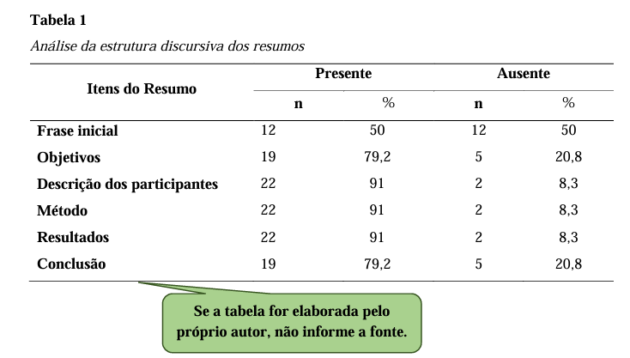

**Figure Title**

The title explains the figure concisely but discursively. The font in the title of the figure should be the same as that used in the text, in bold type and with a spacing of 1.5 cm between the figure number and the title of its identification, which will appear below in left-aligned italics. Numbered with Arabic numerals sequentially within the text as a whole, preceded by the word figure (with the initial capitalization). Example: Figure 1, Figure 2, Figure 3, etc.

The citation font should be bold and simple spaced, below the left-aligned figure, Times New Roman 10 font.

Indicate the source when the figure is extracted from another work (**do not indicate if it is the author's own**). Please reference the consulted document.

Any other information needed for clarification of the figure (such as unit of measurement, symbols, scales and abbreviations), which has not been included in the legend, should be

after the title.

For example figure:

**Figure 1**

*Place where the experiments were conducted.*

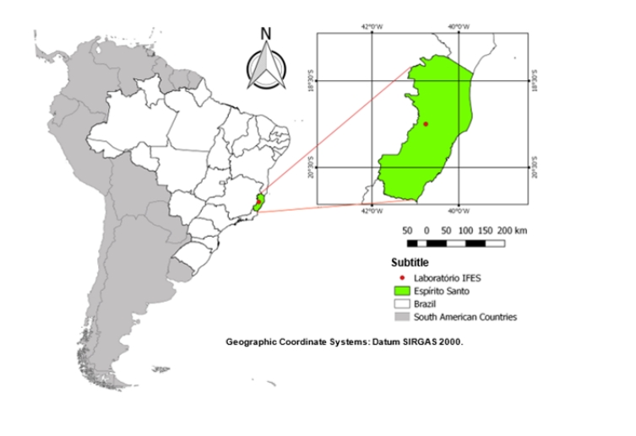

Source: Adapted from PIFFER, P. F. Maps of Brazil. Revista Mundos, v.1 n3, 2023.

**Figure 2**

*Performance of seventh-year students.*

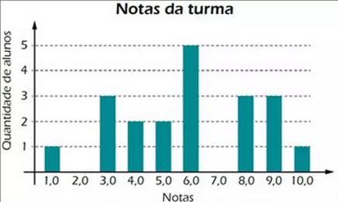

Source: Adapted from PIFFER, P. F. Maps of Brazil. Revista Mundos, v.1 n3, 2023.

**Figure 3**

*Place where the experiments were conducted.*

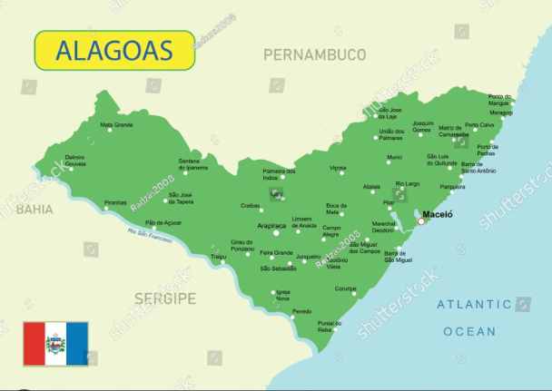

Source: Adapted from PIFFER, P. F. Maps of Brazil. Revista Mundos, v.1 n3, 2023.

Censored (intimate) figures, keep the stripes if the author says so. but if he didn't put it on his private parts, keep it as he ordered. Just take care of the patient's image.

Images taken of people must also have stripes on their faces, considering the protection of identity with respect for dignity and individual freedom.

**Figure 4**

*People walking along Avenida 15 de Novembro*



The illustration shall be quoted in the text and inserted as close as possible to the passage to which it refers.

**Subtitles Section**

Titles must be numbered, in capital letters, in bold, justified with Times New Roman font, size 12.

Subtitles must be numbered, in capital letters, without bold, justified with Times New Roman font, size 12.

Following example:

**Table 2**

*Title formation sequence*

|  |  |
| --- | --- |
| Type | Format |
| Primary Section Title | **INTRODUCTION** |
| Secondary Section Title | **Search Type** |
| Tertiary Section Title | Definition of Concepts |
| Title of the quaternary section | Concept options |
| Title of section quinaria | **Bold and italicized** |
| Title of the senary section | No bold and italics |

**Source:** Derecho, 2024.

The citations in the body of work must follow the standards of the American Psychological Association (APA).

**Direct Citation in the Apa Standards**

The direct citation is the one that transcripts the author's text, without there being any modification. To make this kind of citation according to the APA standards, it is necessary to add the last name of the writer, and then the date of publication of the scientific article, book or internet material.

It is worth pointing out that there is a short direct quote - that is, the one with fewer than 40 words. In this case, you need to write the transcript of the text and enclose it in **quotation marks**.

**For example:**

According to Holland (2021) "digital marketing has grown 80% in the last 5 years promoting the evolution of companies".

Besides the short direct quote, there is also the long one - that is, the one with more than 40 words. In this case, you must include it in a new paragraph and format it as follows:

Indentation of 1.25 cm;

Single spacing;

Size 12;

Times New Roman font.

**For example:**

According to Holland (2021) "digital marketing has grown 80% in the last 5 years promoting the evolution of companies. As a result, sales of its products increased income from revenue and consequently promoted the expansion of jobs generation and regional development."

**Indirect Citation in APA Standards**

The indirect citation consists of writing down a writer's idea, but without transcribing it. In that case, you need to use your own words to present the idea of another author. To make the indirect citation, it is necessary to write the author's surname, and then the year of publication of his work.

**For example:**

According to Holland (2021), digital marketing has grown satisfactorily in the last five years, being 80%.

APA Citation

In order to quote the quote in accordance with the APA rules, it is necessary to include the name of the author of the original text, followed by the term "as quoted in", the name of the author who had access to his work, the year of publication and the page.

**For example:**

Digital marketing has grown satisfactorily in the last five years, with an increase of 80% (Bianca as quoted in Isabella, 2021, p. 59).

Quotation From two Authors in the APA Standards

To quote two authors, it is necessary to enter the last name of the two authors, and then the year of publication. Below are two ways to write this type of quote:

**For example:**

Herculano and Holland (2021) or (Herculano & Holland, 2021)

Citation of Three or More Authors in the APA Standards

When there is a need to quote three or more authors, one must write the last name of the first author and then write the term "et al.". Finally, the year of publication should be included.

**For example:**

Herculano *et al*. (2021) or (Herculano *et al.,* 2021)

**METHODOLOGY**

The methodology of an article outlines the procedures employed to conduct the research, including the type of study, sample selection, data collection and analysis methods, ethical considerations, and limitations of the study. Its detailed and transparent description is essential to guarantee the replicability and reliability of the results, in addition to providing a solid basis for the interpretation and generalization of the findings.

**Formulas and Equation**

In the midst of a text, formulas and equations should be represented in line. A larger spacing should be used to accommodate their elements (exponents, indices, and others). When presented outside the paragraph, they should be left-aligned. If there are multiple formulas or equations, they should be identified with sequential Arabic numerals throughout the text and enclosed in parentheses ( ) at the right end of the line. If formulas or equations are divided into multiple lines due to lack of space, they should be interrupted before the equal sign "=" or after addition and subtraction signs.

Example equation:

C:\Users\maria.bruns\AppData\Local\Microsoft\Windows\Clipboard\HistoryData\{20469AFE-B88C-4954-9384-4B92A81A6EA7}\{EE638172-755C-40CD-88EE-FF54107B5C48}\ResourceMap\{D77016F3-FDA1-4DE6-9CEA-59EA4AE35420}               (1)

where:

d(AB)= slope expressed as a percentage

dV= vertical distance (equidistance)

dH = horizontal distance

Example formula:

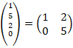                       (2)

**Marker**

Markers are enumerative divisions referring to a period of the paragraph. The following configuration:

a) the text preceding the first marker ends with a colon;

b) they begin at the paragraph indent and are written with normal spacing;

c) they are numbered with lowercase letters in alphabetical order, followed by a closing parenthesis. If the number of bullets exceeds the number of letters in the alphabet, use doubled letters: aa), ab), ac), etc;

d) the text of the marker begins with a lowercase letter, except if it begins with proper names, and is closed with a semicolon, except for the last one, which is closed with a period.

**As in the example below:**

a) markers are spaced at a left indentation of 0.75 by an offset of 0.5;

b) markers are spaced at a left indentation of 0.75 by an offset of 0.5;

c) markers are indented 0.75 to the left by an offset of 0.5.

**RESULTS AND** **DISCUSSIONS**

The results and discussions of an article must be presented in a clear and organized manner, based on the data collected and the analyzes carried out during the study. Initially, the results must be presented in an objective and concise way, using tables, graphs and statistics, if applicable, to highlight the main findings. Then, in the discussion section, the results are interpreted in light of existing literature, highlighting similarities, differences and implications for theory and practice.

Furthermore, limitations of the study and possible directions for future research are discussed. It is essential that both the results and the discussion are based on solid evidence and that they contribute significantly to the advancement of knowledge on the topic addressed.

**CONCLUSION**

The conclusion of an article should summarize the main findings of the study succinctly, highlighting the significant contributions to the research field. It should reiterate the objectives of the study and summarize the most important findings, emphasizing their relevance and practical or theoretical implications.

**ACKNOWLEDGEMENTS**

Optional section, where the author can thank the funding agencies, or other applicable thank you.

**REFERENCES**

References using American Psychological Association (APA) standards, placed in alphabetical order. Justified alignment, in the second line of the reference onwards, an indentation of 0.75 is made. Spacing after 12 points and single line spacing.

**Figure 4**

*Illustration of the location where the reference configuration should be carried out*

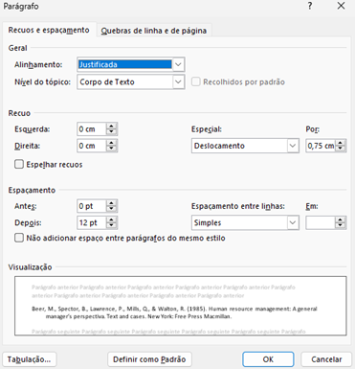

**Example:**

Beer, M., Spector, B., Lawrence, P., Mills, Q., & Walton, R. (1985). *Human resource management:* *A general manager's perspective.* Text and cases. New York: Free Press Macmillan.

**Book Chapter:** Last Name of the Author of the Chapter, First Names. (Year of publication). Title of the chapter. In Initials and Surname of the Book Editor (Ed.), *Title of the book in italics* (chapter pages). Publisher.

**Example:**

Brown, A. C. (2008). The role of technology in modern education. In S. L. Johnson (Ed.), *Technology in Education* (pp. 45-62). Publisher XYZ.

**Journal Article:** Author's Last Name, First Names. (Year of publication). Title of the article. *Title of the Journal in italics*, *volume* (number), start page - end.

**Example:**

Johnson, M. B. (2015). The impact of climate change on marine species. *Journal of Marine Ecology*, *25*(3), 112-130.

**Doctoral Thesis or Dissertation:** Author's Last Name, Initials of the Name. (Defense year). *Title of the thesis or dissertation in italics* (Doctoral Thesis or Master's Dissertation). Name of the Institution.

**Example:**

Silva, R. M. (2017). *Impact of Digital Advertising on Consumer Preferences* (Master's Dissertation). ABC University.

**Book:** Author's Last Name, First Names. (Year of publication). *Book title in italics*. Publisher.

**Example:**

Smith, J. A. (2010). *Applied Psychology*. ABC Publisher.

1. Highest academic qualification, Training institution, City, State, Country.

   E-mail: xxxxx@hotmail.com Orcid: https://orcid.org/0000-0000-0000-0000